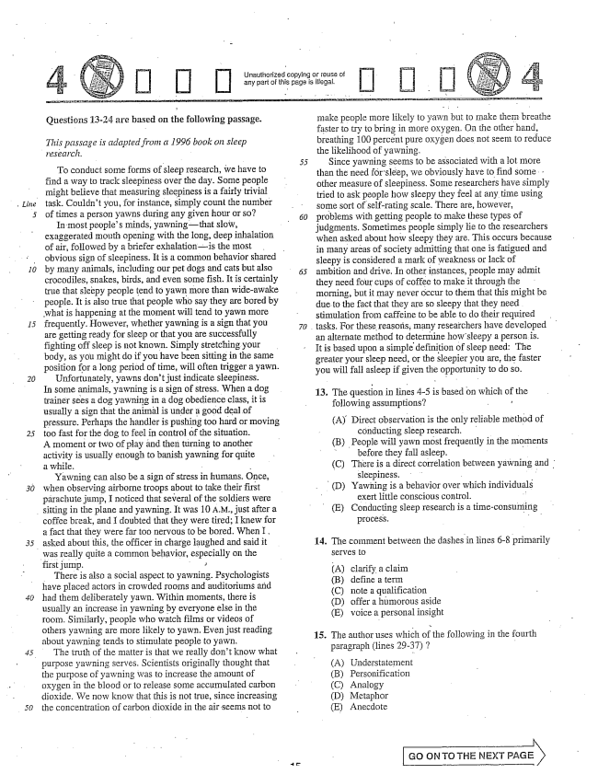

*10*

*15*

*30*

*50*

Unauthorized copying or of any part of this page is illegal.

Questions 13-24 are based on the following passage.

*This passage is adapted from a 1996 book on sleep*

*research.*

To conduct some forms of sleep research, we have to find a way to track sleepiness over the day. Some people might believe that measuring sleepiness is a fairly trivial task. Couldn't you, for instance, simply count the number of times a person yawns during any given hour or so?

In most peoples minds, yawningthat slow, exaggerated mouth opening with the long, deep inhalation of air, followed by a briefer exhalationis the most obvious sign of sleepiness. It is a common behavior shared by many animals, including our pet dogs and cats but also crocodiles, snakes, birds, and even some fish. It is certainly true that sleepy people tend to yawn more than wideawake people. It is also true that people who say they are bored by what is happening at the moment will tend to yawn more frequently. However, whether yawning is a sign that you are getting ready for sleep or that you are successfully fighting off sleep is not known. Simply stretching your body, as you might do if you have been sitting in the same position for a long period of time, will often trigger a yawn.

Unfortunately, yawns don't just indicate sleepiness. In some animals, yawning is a sign of stress. When a dog trainer sees a dog yawning in a dog obedience class, it is usually a sign that the animal is under a good deal of pressure. Perhaps the handler is pushing too hard or moving too fast for the dog to feel in control of the situation. A moment Dr two of play and then turning to another activity is usually enough to banish yawning for quite a while. - -

Yawning can also be a sign of stress in humans. Once, when observing airborne troops about to take their first parachute jump, I noticed that several of the soldiers were

sitting in the plane and yawning. It was 10 A.., just after a

coffee break, and I doubted that they were tired; I knew for a fact that they were far too nervous to be bored. When I, asked about this, the officer in charge laughed and said it was really quite a common behavior, especially on the first jump.

There is also a social aspect to yawning. Psychologists have placed actors in crowded rooms and auditoriums and had them deliberately yawn. Within moments, there is usually an increase in yawning by everyone else in the room. Similarly, people who watch films or videos of others yawning are more likely to yawn. Even just reading about yawning tends to stimulate people to yawn.

The truth of the matter is that we really don't know what

- purpose yawning Serves, Scientists originally thought that

the purpose of yawning was to increase the amount of Oxygen in the blood or to release some accumulated carbon dioxide. We now know that this is not true, since increasing the concentration of carbon dioxide in the air seems not to

make people more Hikely to yawn but to make them breathe faster to try to bring in more oxygen. On the other hand, breathing 100 percent pure oxygen does not seem to reduce the likelihood of yawning.

Since yawning seems to be associated with a lot more than the need for sleep, we obviously have to find some . . other measure of sleepiness. Some researchers have simply tried to ask people how siecpy they feel at any time using some sort of self-rating scale. There are, however, problems with getting people to make these types of judgments. Sometimes people simply lie to the researchers when asked about how sleepy they are. This occurs because in many areas of society admitting that one is fatigued and sleepy is considered a mark of weakness or lack of ambition and drive. In other instances, people may admit they need four cups of coffee to make it through the morning, but it may never occur to them that this might be due to the fact that they are so sleepy that they need stimulation from caffeine to be able to do their required tasks. For these reasois; many researchers have developed an alternate method to determine how sleepy a person is. It is based upon a simple definition of sleep need. The greater your sleep need, or the sleepier you are, the faster you will fall asleep if given the opportunity to do so.

13. The quesion in lines -5 is based on which of the following assumptions? - r

(A) Direct observation is the only reliable method of

conducting Sleep research. (B) People will yawn most frequently in the moments

before they fall asleep. - (C) There is a direct correlation between yawning an

sleepiness. - - (D) Yawning is a behavior over which individuals

exert little conscious control. (E) Conducting sleep research is a timeconsuming

process. .. "

The comment between the dashes in lines -8 primarily SèIVES O

(A) B(C) (D) (E)

. The author uses which of the following in the fourth

paragraph (lines 2937) 7 -

A) Understatement (B) Personification (C) Analogy (D) Metaphor (E) Anecdote

**14.**

clarify a claim define a terIn note a qualification offer a humorous aside voice a personal insight

Go ON TO THE NEXT PAGE X

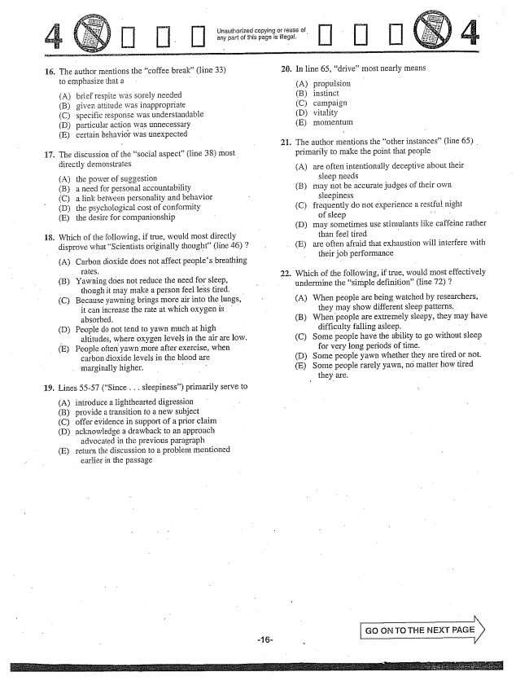

16. The author mentions the coffee break” (line 33)

to emphasize that a -

(B) (C) (D) (E)

brief respite was sorely needed given attitude was inappropriate specific response was understandable particular action was unnecessary certain behavior was unexpected

The discussion of the social aspect" (line 38) most directly demonstrates

17

(A) the power of suggestion (Ba need for personal accountability (C) a link between personality and behavior (D) the psychological cost of conformity (E) the desire for companionship

Which of the following, if true, would most directly disprove what Scientists originally thought” (line 46) 2

18.

(A) Carbon dioxide does not affect peoples breathing

(B) Yawning does not reduce the need for sleep, though it may make a person feel less tired.

(C) Because yawning brings more air into the lungs,

it can increase the rate at which oxygen is absorbed,

D) People do not tend to yawn much at high

altitudes, where oxygen fevels in the air are low.

(E) People often yawn more after exercise, when

carbon dioxide levels in the blood are

marginally higher. - -

19. Lines 55-57 (Since . . . sleepiness) primarily serve to

(A) (B) (C) (D)

(E)

introduce a lighthearted digression provide a transition to a new subject offer evidence in support of a prior claim acknowledge a drawback to an approach

advocated in the previous paragraph return the discussion to a problem mentioned

earlier in the passage -

Unauthorized copying or reuse of any part of this page is illegal.

20. In line 65, drive” most nearly means

1.

(B)

propulsion instinct Campaign vitaÍity

The author mentions the other instances” (line 65) . primarily to make the point that people

(A) are often intentionally deceptive about their

sleep needs may not be accurate judges of their own

sleepiness frequently do not experience a restful night

of sleep . . may sometimes use stimulants like caffeine rather

than feel tired - are often afraid that exhaustion will interfere with

their job performance

(C)

(D)

(E)

. Which of the following, if true, would most effectively

undermine the simple definition(line 72) 7

(A) When people are being watched by researchers, they may show different sleep patterns.

(B) When people are extremely sleepy, they may have difficulty falling asleep, -

(C) Some people have the ability to go without sleep

for very long periods of time.

(D) Some people yawn whether they are tired or not.

(E) Some people rarely yawn, no matter how tired

they are.

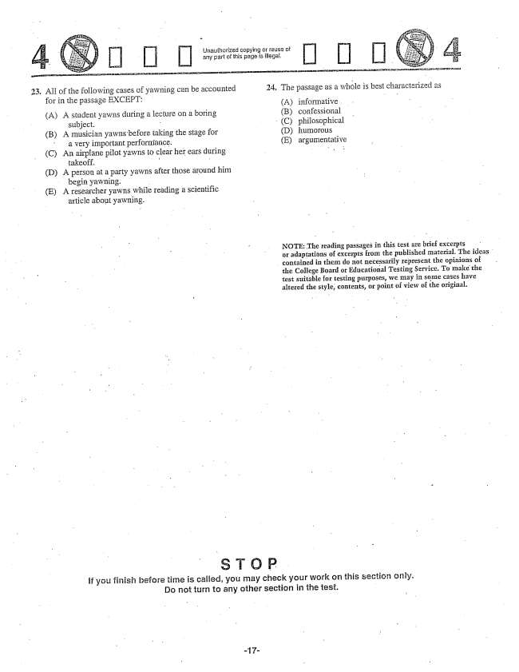

Unauthorized copying or reuse of any part of this page is illega,

23. All of the following cases of yawning can be accounted 24. The passage as a whole is best characterized as

for in the passage EXCEPT: 2- - - -

(A) A student yawns during a lecture on a boring (B) confessional

subject. - (C) philosophical (B) A musician yawns before taking the stage for (D) humorous -

a very important performance. (E) argumentative (C) An airplane pilot yawns to clear her ears during . .

takeoff. - (D) A person at a party yawns after those around him

begin yawning.

(E) A researcher yawns while reading a scientific

article about yawning.

- NOTE: The reading passages in this test are brief excerpts

- or adaptations of excerpts from the published material. The ideas

contained in them do not necessarily represent the opinions of the College Board or Educational Testing Service. To make the test suitable for testing purposes, we may in some cases have altered the style, contents, or point of view of the original.

s то Р

if you finish before time is called, you may check your work on this section oftly. Do not turn to any other section in the test.

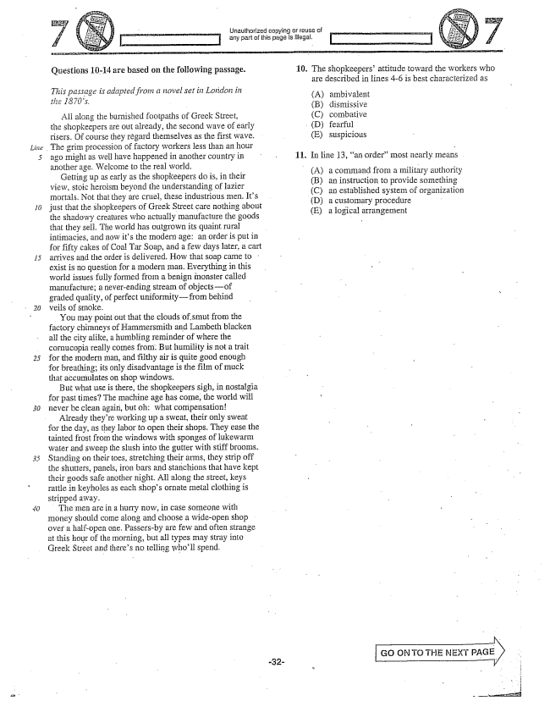

*Line .*

Unauthorized copying Dr reuse of any part of this page is illega.

Questions 10-14 are based on the following passage.

*This passage is adapted from a novel set in London in the 1870.*

All along the burnished footpaths of Greek Street, the shopkeepers are out already, the Second wave of early risers. Of course they regard themselves as the first wave. The grim procession of factory workers less than an hour ago might as well have happened in another country in another age. Welcome to the real world.

Getting up as early as the shopkeepers do is, in their view, stoic heroism beyond the linderstanding of lazier mortals. Not that they are cruel, these industrious men. Its just that the shopkeepers of Greek Street care nothing about the shadowy creatures who actually manufacture the goods that they sell. The world has outgrown its quaint rural intimacies, and now its the modern age: an order is put in for fifty cakes of Coal Tar Soap, and a few days later, a cart arrives and the order is delivered. How that soap came to : exist is no question for a modern man. Everything in this world issues fully formed from a benign inonster called manufacture; a neverending stream of objectsof graded quality, of perfect uniformityfrom behind veils of SrIIoke.

You may point out that the clouds of Smut from the factory chimneys of Hammersmith and Lambeth blacken all the city alike, a humbling reminder of where the cornucopia really cornes from. But humility is not a trait for the modern man, and filthy air is quite good enough for breathing; its only disadvantage is the film of muck that accumulates on shop windows.

But what use is there, the shopkeepers sigh, in nostalgia for past times? The machine age has come, the world will never be clean again, but Oh: what compensation

Already theyre working up a sweat, their only sweat for the day, as they labor to open their shops. They ease the tainted frost from the windows with sponges of lukewarm water and sweep the slush into the gutter with stiff brooms. Standing on their toes, stretching their arms, they strip off the shutters, panels, iron bars and stanchions that have kept their goods safe another night. All along the street, keys rattle in keyholes as each shops ornate metal clothing is Stripped away.

The men are in a hurry now, in case someone with money should come along and choose a wideopen shop over a half-open one. Passers-by are few and often strange at this hour of the morning, but all types may stray into Greek Street and theres no telling wholl spend.

10. The shopkeepersattitude toward the workers who

are described in fines -6 is best characterized as

. In line 13, an orderInost nearly Imeans

(A) a command from a military authority (B) an instruction to provide something (C) an established system of organization (D) a customary procedure (E) a jogical arrangement

Go ON TO THE NEXT PAGE

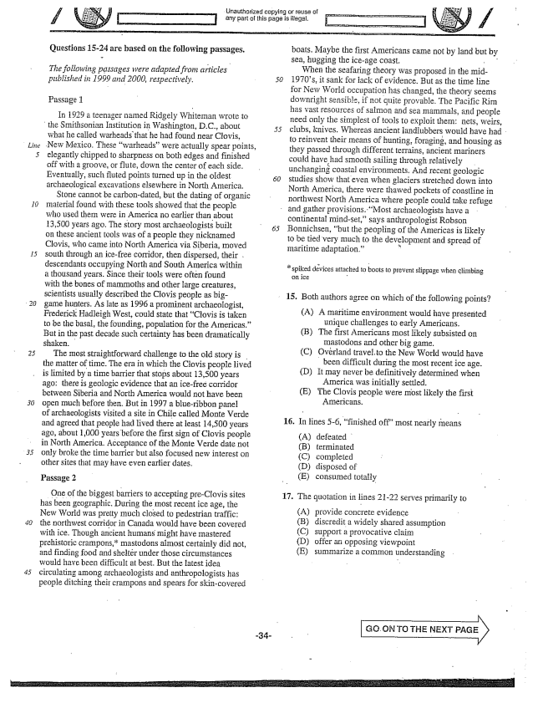

*Linie*

Questions 15-24 are based on the following passages.

*The following passages were adapted from articles - published in 1999 and 2000, respectively.*

Passage 1

In 1929 a teenager named Ridgely Whiteman wrote to

the Smithsonian Institution in Washington, DC., about

what he called warheads that he had found near Clovis,

New Mexico. These warheads” were actually spear points,

elegantly chipped to sharpness on both edges and finished off with a groove, or flute, down the center of each side. Eventually, such fluted points turned up in the oldest archaeological excavations elsewhere in North America.

Stone cannot be carbon-dated, but the dating of organic material found with these tools showed that the people who used them were in America no earlier than about 13,500 years ago. The story most archaeologists built on these ancient tools was of a people they nicknamed Clovis, who came into North America via Siberia, moved south through an ice-free corridor, then dispersed, their . descendants occupying North and South America within a thousand years. Since their tools were often found with the bones of mammoths and other large creatures, scientists usually described the Clovis people as biggame hunters. As late as 1996 a prominent archaeologist, Frederick Hadleigh West, could state that Clovis is taken to be the basal, the founding, population for the Americas.” But in the past decade such certainty has been dramatically shaken.

The most straightforward challenge to the old story is the matter of time. The era in which the Clovis people lived is limited by a time barrier that stops about 13,500 years

ago: there is geologic evidence that an ice-free corridor

between Siberia and North America would not have been open much before then. But in 1997 a blueribbon panel of archaeologists visited a site in Chile called Monte Verde and agreed that people had lived there at least 14,500 years ago, about 1,000 years before the first sign of Clovis people in North America. Acceptance of the Monte Verde date not only broke the time barrier but also focused new interest on other sites that may have even earlier dates.

Passage 2

One of the biggest barriers to accepting pre-Clovis sites has been geographic. During the most recent ice age, the New World was pretty much closed to pedestrian traffic: the northwest corridor in Canada would have been covered with ice. Though ancient humans might have mastered prehistoric crampons,mastodons almost certainly did not, and finding food and sheltér under those circumstances would have been difficult at best. But the latest idea circulating among archaeologists and anthropologists has people ditching their crampons and spears for skincovered

unauthorized copying or reuse of

any part of this page is illegal.

*50*

boats, Maybe the first Americans came not by land but by Sea, hugging the ice-age coast. When the seafaring theory was proposed in the mid1970s, it sank for lack of evidence. But as the time line for New World occupation has changed, the theory seems downright sensible, if not quite provable. The Pacific Rim has vast resources of salmon and sea mammals, and people need only the simplest of tools to exploit them: nets, weirs, clubs, knives. Whereas ancient landlubbers would have had to reinvent their means of hunting, foraging, and housing as they passed through different terrains, ancient mariners could have had smooth sailing through relatively unchanginġ coastal environments. And recent geologic studies show that even when glaciers stretched down into North America, there were thawed pockets of coastline in northwest North America where people could take refuge

and gather provisions. Most archaeologists have a

continental mindset,says anthropologist Robson Bonnichsen, but the peopling of the Americas is likely to be tied very much to the development and spread of Inaritime adaptation.” *

spiked devices attached to boots to prevent slippage when climbing

on ice -

15. Both authors agree on which of the following points?

(A) A maritime environment would have presented unique challenges to early Americans.

(B) The first Americans most likely subsisted on

mastodons and other big game.

(C) Overland , to the New World would have

been difficult during the most recent ice age.

(D) It may never be definitively determined when

America was initially settled.

(E) The Clovis people were most likely the first

Americans.

In lines -6, finished off" most nearly means

(A) defeated (B) terminated (C) completed (D) disposed of (E) consumed totally

**16.**

17. The quotation in lines 21-22 serves primarily to

(A) provide concrete evidence (B) discredit a widely shared assumption (C) support a provocative claim (D) offer an opposing viewpoint (E) summarize a common understanding

, ON TO THE NEXT PAGE

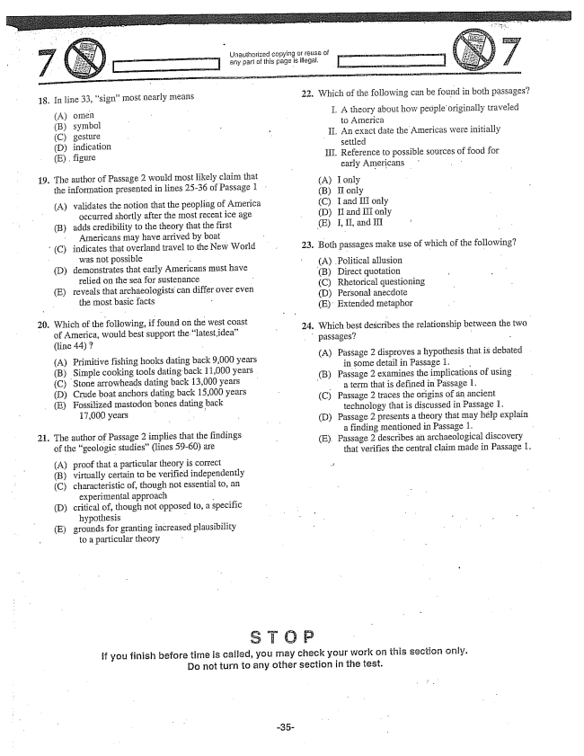

18,

19.

20.

(X)

In line 33, signmost nearly means

(A) omen (B) symbol (C) gesturë (D) indication (E), figure

The author of Passage 2 would most likely claim that the information presented in lines 25-36 of Passage 1

(A) validates the notion that the peopling of America

occurred shortly after the most recent ice age

(B) adds credibility to the theory that the first

AImericans may have arrived by boat

(C) indicates that overland travel to the New World

was not possible

(D) demonstrates that early Americans must have

relied on the sea for sustenance (E) reveals that archaeologists can differ over even

the most basic facts -

Which of the following, found on the west coast of America, would best support the latest idea” (line 44) 7

(A) Primitive fishing hooks dating back ,000 years

(B) Simple cooking tools dating back 11,000 years

(C) Stone arrowheads dating back 13,000 years

(D) Crude boat anchors dating back 15,000 years

(E) Fossilized mastodon bones dating back

17,000 years :

. The author of Passage 2 implies that the findings

of the geologic studies” (lines 59-60) are

(A) proof that a particular theory is correct

(B) virtually certain to be verified independently

(C) characteristic of, though not essential to, an experimental approach -

(D) critical of, though not opposed to, a specific

hypothesis -

E) grounds for granting increased plausibility

to a particular theory

Unauthorized copying or reuse of

| T] any part of this page is illegal,

22.

23.

**24.**

passages?

Which of the following can be found in both passages?

I. A theory about how people originally traveled

to America II. An exact date the Americas were initially

settled III. Reference to possible Sources offood for

early Americans . .

(A) I only (B) II only (C) I and III only (D) II and III only

(E) I, II, and III .

Both passages make use of which of the following?

(A) Political allusion

(B) Direct quotation

(C) Rhetorical questioning (D) Personal anecdote (E) Extended metaphor

Which best describes the relationship between the two -

A) Passage 2 disproves a hypothesis that is debated

in some detail in Passage 1.

(B) Passage 2 examines the implications of using

a term that is defined in Passage i. (C) Passage 2 traces the origins of an ancient

technology that is discussed in Passage 1, D) Passage 2 presents a theory that may help explain

a finding mentioned in Passage 1. - (E) Passage 2 describes an archaeological discovery

that verifies the central claim made in Passage 1.

if you finish before time is called, you may check your work on this section only. Do not turn to any other section in the test.

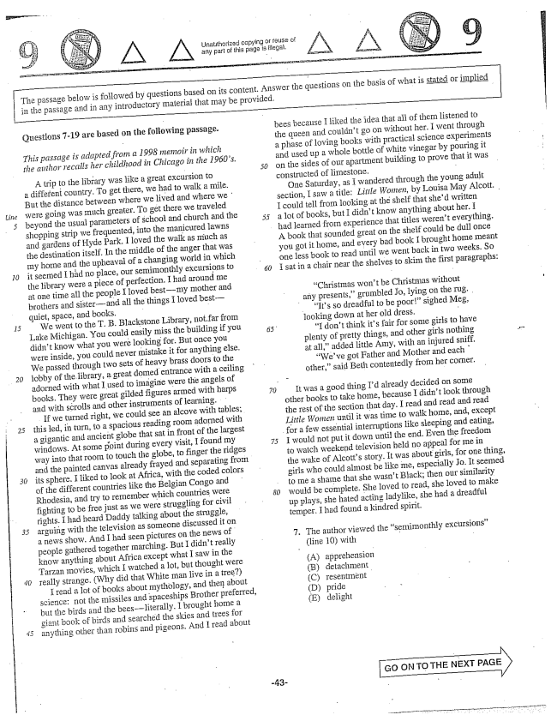

*line*

*30*

Unatthorized copying or any part of this page is illegal,

The passage below is followed by questions based on its content, Answer the questions on the basis of what is Stated Or implied in the passage and in any introductory material that may be provided.

Questions -19 are based on the following passage.

*This passage is adapted from a 1998 memoir in which the author recalls her childhood in Chicago in the 1960s,*

A trip to the library was like a great excursion to a different country. To get there, we had to walk a mile. But the distance between where we lived and where we were going was much greater. To get there we traveled beyond the usual parameters of school and church and the shopping strip we frequented, into the manicured lawns and gardens of Hyde Park. I loved the walk as much as the destination itself. In the middle of the anger that was my home and the upheaval of a changing world in which it seemed I had no place, our semimonthly excursions to the library were a piece of perfection. I had around me at one time all the people I loved bestmy mother and brothers and sisterand all the things I loved bestquiet, space, and books. - -

We went to the T. B. Blackstone Library, not, far from Lake Michigan. You could easily miss the building if you didn't know what you were looking for. But once you were inside, you could never mistake it for anything else. We passed through two sets of heavy brass doors to the lobby of the library, a great domed entrance with a ceiling adorned with what I used to imagine were the angels of books. They were great gilded figures armed with harps and with scrolls and other instruments of learning.

If we turned right, we could see an alcove with tables; this jed, in turn, to a spacious reading room adorned with a gigantic and ancient globe that sat in front of the largest windows. At some point during every visit, I found my way into that room to touch the globe, to finger the ridges

and the painted canvas already frayed and separating from

its sphere. I liked to look at Africa, with the coded colors of the different countries like the Belgian Congo and Rhodesia, and try to remember which countries were fighting to be free just as we were struggling for civil rights. I had heard Daddy talking about the struggle, arguing with the television as someone discussed it on a news show. And I had seen pictures on the news of people gathered together marching. But I didn't really know anything about Africa except what I saw in the Tarzan movies, which I watched a lot, but thought were really strange. (Why did that White man five in a tree)

I read a lot of books about mythology, and then about Science: not the missiles and spaceships Brother preferred, but the birds and the beesliterally. I brought home a giant book of birds and searched the skies and trees for anything other than robins and pigeons. And ITéad about

bees because I liked the idea that all of them listened to the queen and couldnt go on without her. I went through a phase of loving books with practical science experiments and used up a whole bottle of white vinegar by pouring it on the sides of our apartment building to prove that it was constructed of limestone. -

One Saturday, as I wandered through the young adult Section, I saw a title: Little Women, by Louisa May Alcott. I could fell from looking at the shelf that shed written a lot of books, but I didn't know anything about her. I had learned from experience that titles werent everything. A book that sounded great on the shelf could be dull once you got it home, and every bad book I brought home meant

one less book to read until we went back in two weeks. So

I sat in a chair near the shelves to skim the first paragraphs:

“Christmas wont be Christmas without

any presents,grumbled Jo, lying on the rug. . Its so dreadful to be poor” sighed Meg,

looking down at her old dress. -

I don't think its fair for some girls to have plenty of pretty things, and other girls nothing at all,added little Amy, with an injured sniff.

Weve got Father and Mother and each other,said Beth contentedly from her corner.

It was a good thing Id already decided on some other books to take home, because I didnt look through the rest of the section that day. I read and read and read Little Women until it was time to walk home, and, except

for a few essential interruptions like sleeping and eating,

I would not put it down until the end. Even the freedom to watch weekend television held no appeal for me in the wake of Alcotts story. It was about girls, for one thing, girls who could almost be like me, especially Jo. It seemed to me a shame that she wasn't Black; then our similarity would be complete. She loved to read, she loved to make up plays, she hated acting ladylike, she had a dreadful temper. I had found a kindred spirit.

7. The author viewed the semimonthly excursions” (line 10) with -

A) apprehension (B) detachment (C) resentmënt (D) pride (E) delight

oN TOTHE NEXT PAGE

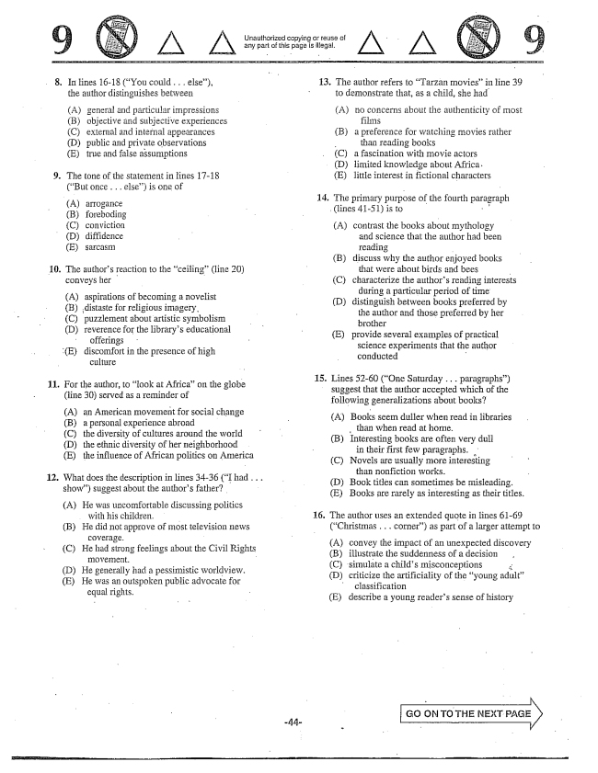

. In lines 16-18 (You could . . . else),

the author distinguishes between

(A) general and particular impressions (B) objective and subjective experiences (C) external and internal appearances (D) public and private observations (E) true and false assumptions

9. The tone Of the staternent in lines 1718

(But once . . . else) is one of

(А) апоgance (B) foreboding (C) conviction (D) diffidence (E) sarcasm

10. The authors reaction to the ceiling" (line 20)

conveys her

(A) aspirations of becoming a novelist

(B) distaste for religious imagery.

(C) puzzlement about artistic symbolism

(D) reverence for the librarys educational

offerings

(E) discomfort in the presence of high

culture

11. For the author, to look at Africa" on the globe

(line 30) served as a reminder of

(A) an American movement for social change (B) a personal experience abroad (C) the diversity of cultures around the world (D) the ethnic diversity of her neighborhood (E) the influence of African politics on America

12. What does the description in lines 34-36 (I had . . .

show) suggest about the authors father?

(A) He was uncomfortable discussing politics

with his children. -

(B) He did not approve of most television news

coverage.

(C) He had strong feelings about the Civil Rights

(D) He generally had a pessimistic worldview. (E) He was an outspoken public advocate for

equal rights.

Unauthorized copying or reuse of ^

any part of this page is illegål.

13. The author refers to Tarza It Inovies” in fine 39

to demonstrate that, as a child, she had

(A) no concerns about the authenticity of most

(B) a preference for watching movies rather

- than reading books

(C) a fascination with movie actors

(D) limited knowledge about Africa.

(E) little interest in fictional characters

. The primary purpose of the fourth paragraph

(lines 41-51) is to ,

A) contrast the books about mythology

and science that the author had been

reading - (B) discuss why the author enjoyed books

that were about birds and bees - (C) characterize the authors reading interests during a particular period of time (D) distinguish between books preferred by

the author and those preferred by her brother (E) provide several examples of practical science experiments that the author conducted

. Lines 52-60 (One Saturday . . . paragraphs)

suggest that the author accepted which of the following generalizations about books?

(A) Books seem duller when read in libraries

, than when read at home. (B) Interesting books are often very dull in their first few paragraphs. (C) Novels are usually more interesting

than nonfiction works. (D) Book titles can sometimes be misleading. (E) Books are rarely as interesting as their titles.

. The author uses an extended quote in lines 61-69

(Christmas . . . corner) as part of a larger attempt to

(A) convey the impact of an unexpected discovery (B) illustrate the suddenness of a decision (C) simulate a childs misconceptions - D) criticize the artificiality of the young adult”

classification (Edescribe a young readers sense of history

Go on. To THE NEXT

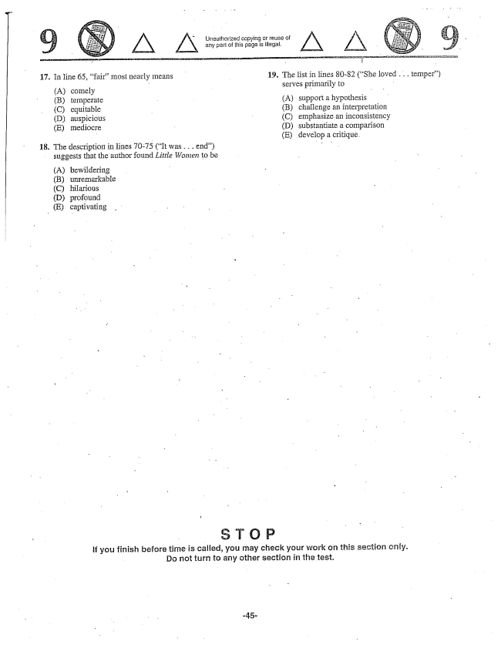

Unauthorized copying or reuse of any part of this page is illegal. Z

19. The list in lines 80-82 (She loved . . . temper)

serves primarily to

17. In line 65, fair” most nearly means

(A) comely - B) temperate - A) support a hypothesis

(C) equitable B) challenge an interpretation

(C) emphasize an inconsistency (D) substantiate a comparison

(E) develop a critique.

(D) auspicious (E) mediocre

The description in lines 70-75 (It was . . . end) suggests that the author found Little Women to be

18

(A) bewildering (B) unremarkable (C) hilarious (D) profound (E) captivating

if you finish before time is called, you may check your work on this section ch. Do not turn to any other section in the test.

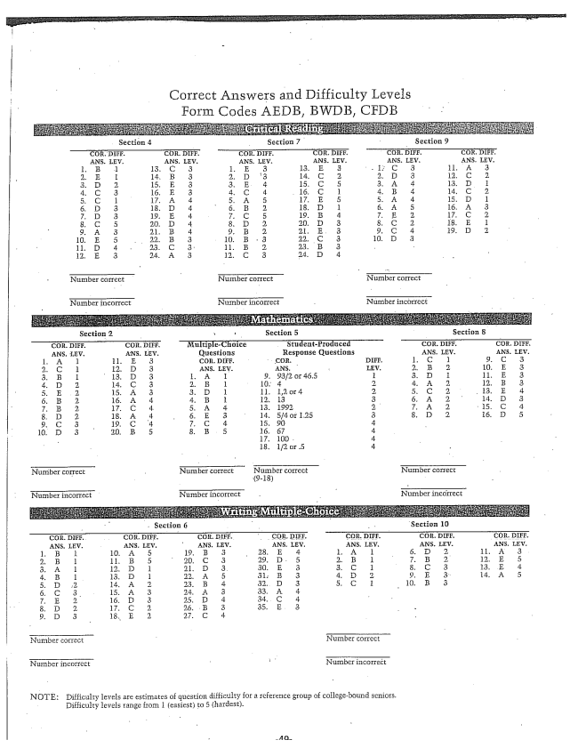

Correct Answers and Difficulty Levels

Form Codes

EDB, BWDB, CFDB

Number correct

Number incorrect

Nürnber correct

Number incorrect

Number correct

Number incorrect

Number correct

Number incorrect

Nurnber correct

(9.18)

Number incorrect

Number correct

Section 10

NHITher correct

Number incorrect

Nurnber correct

Numper incorrect

NOTE: Difficulty levels are estimates of question difficulty for a reference group of collegebound seniors.

Ilifficulty levels range from 1 (easiest) to 5 (hardest.

Number correct

Number incorrect